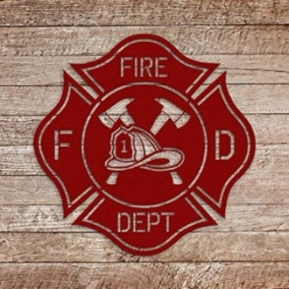

***Cushing Fire Department***

***From the Desk of the Fire Chief:***

**The Cushing Fire Department is asking for your support in the up coming vote for the purchase of a new Fire Truck. Currently the fire department has 3 fire trucks. The oldest one being almost 30 years old and needing costly repairs, I am not confident in its safety and ability to get the job done in the event of a fire. This new fire truck would hold twice as much water, allowing us to gain control quicker of a fire scene. More up to date safety features from both vehicle and personnel stand points. Another point I would like to mention is with a newer apparatus most homeowner’s insurance companies will offer a better price on your policy. The best part of this purchase is not only reliable equipment, but this purchase will in no way increase anyone’s property taxes. It takes approximately 12 months after you order a fire truck before delivery. My hope is to have community support for this purchase so we can order this in March to get this process started. I take the responsibility profoundly serious as being your Fire Chief. I want to be confident that in the unfortunate event of a Fire that I have the appropriate equipment to get the job done.**

**Thank you in advance for your consideration,**

***Chief Flanders***

**Cushing Fire Department**